|  |
| --- |
| **Onions, 16** |

|  |
| --- |
| **Carrots, 16** |

|  |
| --- |
| **Beets, 16** |

|  |
| --- |
| **Broccoli, 1** |

|  |
| --- |
|  |

|  |
| --- |
|  |

|  |
| --- |
|  |

|  |
| --- |
| **Lettuce, 4** |

|  |
| --- |
| **Spinach, 9** |

|  |
| --- |
|  |

|  |
| --- |
| **Cabbage, 1** |

|  |
| --- |
| **Cauliflower, 1** |

|  |
| --- |
|  |

|  |
| --- |
|  |

|  |
| --- |
|  |

|  |
| --- |
|  |

|  |
| --- |
|  |

|  |
| --- |
|  |

|  |
| --- |
|  |

|  |
| --- |
|  |

|  |
| --- |
|  |

|  |
| --- |
|  |

|  |
| --- |
|  |

|  |
| --- |
|  |

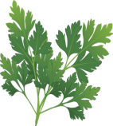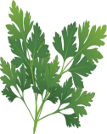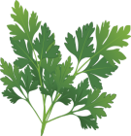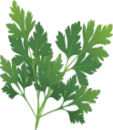

**Parsley, 4**



**Parsley, 4**



**Radishes, 16**



**Strawberry, 4**



**Strawberry, 4**

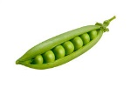

**Peas, 8**

**We don’t like the heat . . . Plant us spring and fall!**

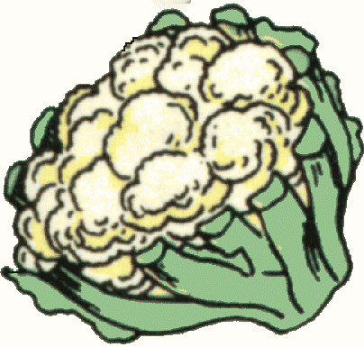

**Cauliflower, 1**

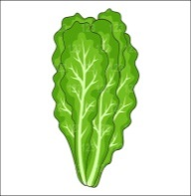

**Lettuce, 4**

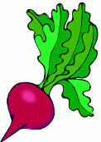

**Beets, 16**

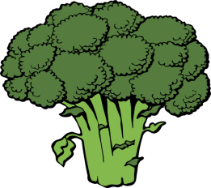

**Broccoli, 1**



**Cabbage, 1**



**Carrots, 16**



**Onions, 16**



**Peas, 8**

**(vertical)**



**Spinach, 9**



**Radishes, 16**